|  |
| --- |
| **Neha Malhotra**  **R.L. Institute M: 9416974837**  **Class : XII**  **“BIOTECHNOLOGY: PRINCIPLES AND PROCESSES”** |

**Level – 1**

**(Based on Principles of Biotechnology and Restriction Enzymes)**

1. The control use of biocontrol agents, such as live organisms or enzymes from organisms to produce products and processes for human welfare is called as :

|  |  |  |  |
| --- | --- | --- | --- |
| a) Biochemistry | b) Molecular biology | c) Biotechnology | d) Microbiology |

1. The techniques/processes that are used under biotechnology are :

|  |  |  |  |
| --- | --- | --- | --- |
| a) In vitro fertilization | b) Correct gene defect | c) Synthesizing a gene | d) all of these |

1. EFB stands for :

|  |  |
| --- | --- |
| a) European Federation of Biotechnology | b) Eurasian Federation of Biotechnology |
| c) East Asia Federation of Biotechnology | d) Ethiopian Federation of Biotechnology |

1. The definition of biotechnology given by EFB encompasses:

|  |  |
| --- | --- |
| a) Traditional biotechnology | b) Modern molecular biotechnology |
| c) DNA fingerprinting | d) Both (a) and (b) |

1. The two main techniques that are gave birth to modern biotechnology are :

(i) Bioprocessing engineering (ii) genetic engineering (iii) Human genome engineering

(iv) Molecular engineering ; Select the correct option:

|  |  |  |  |
| --- | --- | --- | --- |
| a) (i) and (ii) | b) (i) and (iii) | c) (ii) and (iv) | d) (ii) and (iii) |

1. Genetic engineering techniques includes :

|  |  |
| --- | --- |
| a) Altering genetic material | b) sequencing genetic material |
| c) Studying genetic material | d) None of the above |

1. The specific sequence of DNA that initiate replication of alien DNA in r DNA technology is called as :

|  |  |  |  |
| --- | --- | --- | --- |
| a) Initiation sequence | b) Origin of replication | c) Origin of DNA | d) Initiation of DNA |

1. Autonomously replicating circular extra-chromosomal DNA is :

|  |  |  |  |
| --- | --- | --- | --- |
| a) Vector | b) capsid | c) plasmid | d) Bacteriophage |

1. The construction of the first r-DNA are done by using the native plasmid of :

|  |  |
| --- | --- |
| a) E.coli | b) Salmonella typhimurium |
| c) Bacillus thuringiensis | d) Yeast |

1. The first r-DNA was constructed by :

|  |  |  |  |
| --- | --- | --- | --- |
| a) Cohen | b) Boyer | c) Temin and Baltimore | d) Both (a) and (b) |

1. The linking of antibiotic resistance gene with the plasmid vector became possible with

|  |  |  |  |
| --- | --- | --- | --- |
| a) DNA ligase | b) RNA ligase | c) DNA polymerase | d) RNA polymerase |

BIOTECHNOLOGY : PRINCIPLES AND PROCESSES Page No. 1

1. The key tools required for the recombinant DNA technology are :

(i) Restriction enzymes (ii) Polymerase enzymes (iii) Ligases (iv) Vector (v) Host

Select the correct option :

|  |  |  |  |
| --- | --- | --- | --- |
| a) (i) , (ii) , (iii) | b) (i) , (iii) , (iv) , (v) | c) (i) , (ii) , (iii) , (v) | d) (i) , (ii) , (iii) , (iv) , (v) |

1. The enzymes, commonly used in genetic engineering are :

|  |  |
| --- | --- |
| a) Restriction endonucleases and polymerase | b) Endonucleases and ligase |
| c) Restriction endonucleases and ligase | d) Ligase and polymerase |

1. The first restriction endonuclease to be discovered is :

|  |  |  |  |
| --- | --- | --- | --- |
| a) Hind III | b) Hind II | c) Eco RI | d) Eco RII |

1. Which of the following is a restriction endonucleases?

|  |  |  |  |
| --- | --- | --- | --- |
| a) Protease | b) DNase I | c) RNase | d) Hind II |

1. The restriction enzyme responsible for the cleavage of following sequence is :

5’ – G T C G A C – 3’

3’ – C A G C T G – 5’

|  |  |  |  |
| --- | --- | --- | --- |
| a) Alu I | b) Bam HI | c) Hind II | d) Eco RI |

1. How many restriction enzymes are isolated till now?

|  |  |  |  |
| --- | --- | --- | --- |
| a) 920 | b) 940 | c) 900 | d) 230 |

1. Number of bacterial strains from which restriction enzymes has been isolated.

|  |  |  |  |
| --- | --- | --- | --- |
| a) 230 | b) 250 | c) 200 | d) 220 |

1. In the naming of restriction enzymes, the first letter of the name is derived from ___A___ and next two letters from the name ___B___ and fourth letters from the name of ____C___ of ___D___ from which the enzymes are isolated. A to D statement can be :

|  |  |  |  |  |
| --- | --- | --- | --- | --- |
|  | A | B | C | D |
| (a) | Genus | Species | Strain | Bacteria |
| (b) | Species | Genus | Strain | Bacteria |
| (c) | Genus | Species | Variety | Eukaryote |
| (d) | species | genus | variety | Eukaryote |

1. There is a restriction enzyme called Eco RI. What does ‘co’ stands for?

|  |  |  |  |
| --- | --- | --- | --- |
| a) Coelom | b) strain of bacterium | c) Coli | d) Colon |

1. The Roman number following the name of restriction enzyme indicate:
2. Order in which enzyme is isolated from strain of bacteria.
3. Number of enzyme
4. Order of enzyme
5. None of these
6. Restriction enzyme belongs to which class of enzymes?

|  |  |  |  |
| --- | --- | --- | --- |
| a) Ligases | b) exonucleases | c) Nucleases | d) Proteases |

1. In a genetic engineering experiment, restriction enzymes can be used for:

|  |  |  |  |
| --- | --- | --- | --- |
| a) Bacterial DNA only | b) Viral DNA only | c) any DNA fragment | d) Eukaryotic DNA only |

1. Restriction endonucleases are enzymes which :
2. Makes cuts at any position within the DNA molecule.
3. Recognize a specific nucleotide sequence for binding and then cleaves both the strands of DNA.
4. Restrict the action of the enzyme DNA polymerase.
5. Remove nucleotides from the ends of the DNA molecule.

BIOTECHNOLOGY : PRINCIPLES AND PROCESSES Page No. 2

1. An enzyme catalysing the removal of nucleotides from ends of DNA is :

|  |  |  |  |
| --- | --- | --- | --- |
| a) DNA ligase | b) endonuclease | c) exonuclease | d) Protease |

1. Restriction endonucleases enzymes are used to cut :

|  |  |  |  |
| --- | --- | --- | --- |
| a) ss RNA | b) ds DNA | c) ss DNA | d) ds RNA |

1. Restriction endonuclease binds to DNA and cuts two strands of double helix at specific points in their:

|  |  |
| --- | --- |
| a) Sugar – phosphate backbone | b) Hydrogen bond |
| c) Glycosidic bond | d) None of the above |

1. Special sequence in the DNA recognized by restriction endonuclease is called :

|  |  |
| --- | --- |
| a) Restriction nucleotide sequence | b) Palindromic nucleotide sequence |
| c) Recognition nucleotide sequence | d) all of the above |

1. Palindromic sequences :
2. Read opposite on two strands.
3. Read specific sequence in opposite direction.
4. Read same on two strands when orientation of reading is same.
5. Read opposite on two strands when orientation of reading is same.
6. Restriction enzymes cuts the DNA strand a little away from the center of palindrome site between:

|  |  |
| --- | --- |
| a) Same two bases on same strand | b) Same two bases on opposite strand |
| c) Opposite bases on same strand | d) Opposite bases on opposite strand |

1. Study the given diagram and identify the enzymes A and B involved in step I and II.

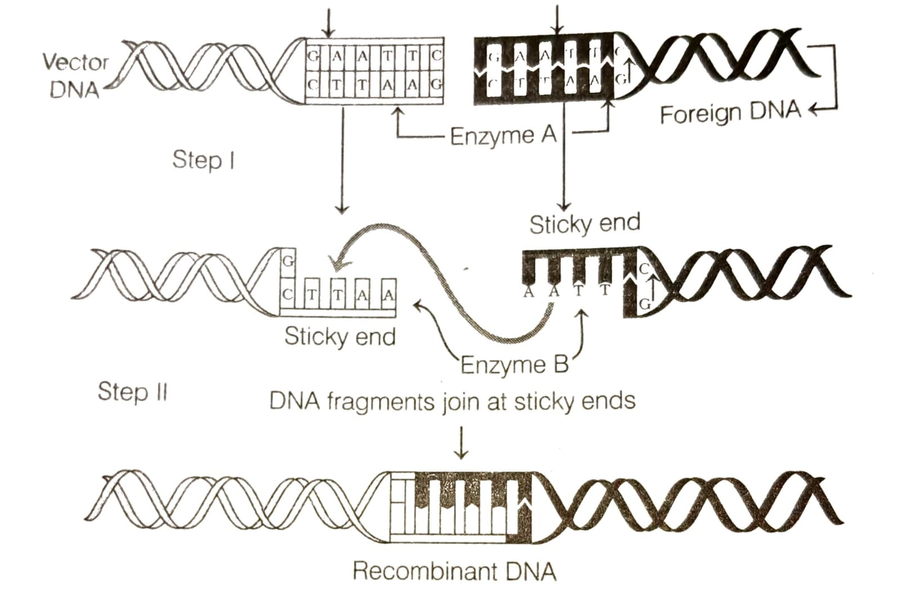

|  |  |  |
| --- | --- | --- |
|  | Step I | Step II |
| (a) | Eco RI | DNA ligase |
| (b) | Alu I | DNA ligase |
| (c) | Hind II | DNA polymerase |
| (d) | Restriction endonucleases | DNA polymerase |

BIOTECHNOLOGY : PRINCIPLES AND PROCESSES Page No. 3

1. The foreign DNA and Vector is cut with the

|  |  |
| --- | --- |
| a) Two different enzymes | b) Same restriction enzymes |
| c) DNA ligase | d) Both (a) and (b) |

1. How many fragments will be generated, if a linear DNA molecule is digested with a restriction enzymes having 4 recognition sites on the DNA?

|  |  |  |  |
| --- | --- | --- | --- |
| a) 3 | b) 5 | c) 4 | d) 6 |

1. How many fragments will be generated, if a closed circular DNA molecule is digested with a restriction enzymes having 6 recognition sites on the DNA ?

|  |  |  |  |
| --- | --- | --- | --- |
| a) 4 | b) 6 | c) 3 | d) 5 |

1. A foreign DNA and plasmid cut by the same restriction endonucleases can be joined to form a recombinant plasmid using :

|  |  |  |  |
| --- | --- | --- | --- |
| a) Eco RI | b) Taq polymerase | c) polymerase III | d) ligase |

1. Which is also called as molecular glue?

|  |  |  |  |
| --- | --- | --- | --- |
| a) DNA gyrase | b) DNA helicase | c) DNA ligase | d) DNA polymerase |

1. Which of the following option(s) is not correctly regarding Eco RI enzymes?

|  |  |
| --- | --- |
| a) Restriction endonuclease enzyme | b) Isolation from Escherichia coli RY13 |
| c) Cuts at specific position with in the DNA | d) None of the above |

1. The flowchart given below represents the process of recombinant technology. Identify A to D in the given process.

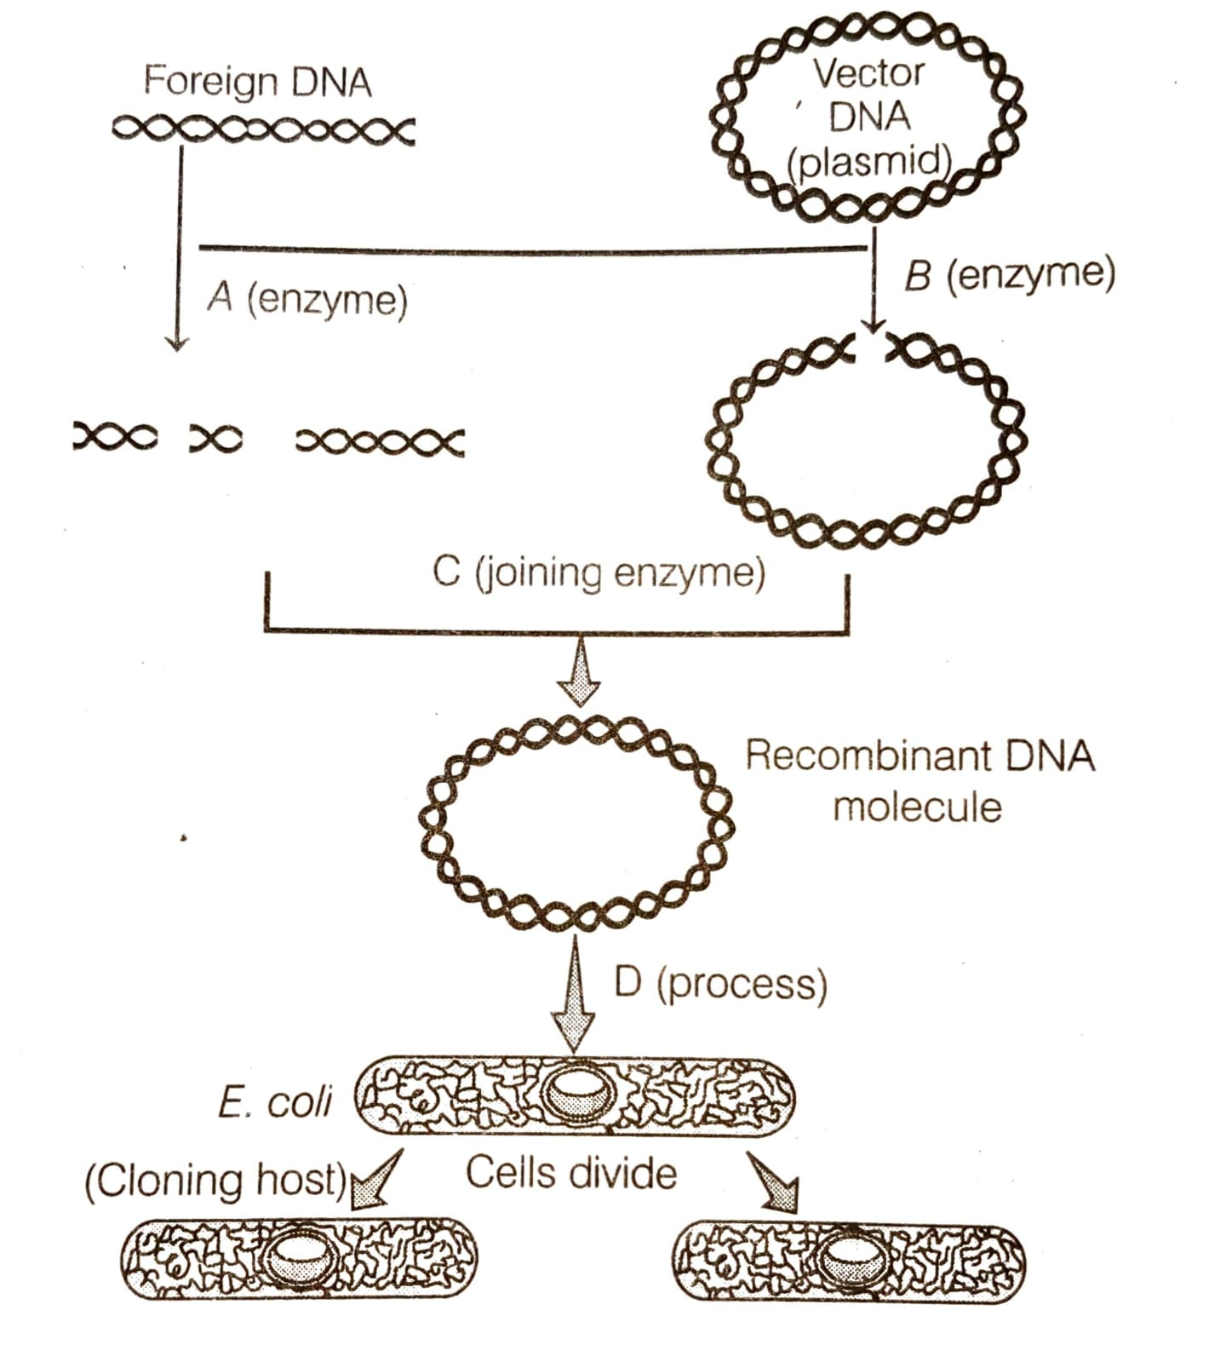

1. A – Restriction endonuclease ; B – Restriction exonuclease ; C – RNA ligase ; D – Transformation.
2. A – Restriction endonuclease ; B – Restriction endonuclease ; C – DNA ligase ; D – Transformation.
3. A – Restriction exonuclease ; B – Restriction endonuclease ; C – DNA Polymerase ; D – Transduction.
4. A – Restriction endonuclease ; B – Restriction exonuclease ; C – DNA ligase ; D – Transformation.

BIOTECHNOLOGY : PRINCIPLES AND PROCESSES Page No. 4

1. Following statement describe the characteristics of the enzyme restriction endonucleases. Identify the incorrect statement.
2. The enzyme binds DNA at specific sites and cuts only one of the two strands.
3. The enzyme cuts the sugar-phosphate backbone at specific sites on each strand.
4. The enzyme recognizes a specific palindromic sequence in the DNA.
5. The enzyme cuts DNA molecules at identified position within the DNA.
6. Which of the following statement is incorrect?
7. Each restriction endonuclease recognized a specific palindromic nucleotide sequence.
8. Specific base sequence is known as recognition sequence.
9. Restriction enzymes cannot cut DNA.
10. Restriction enzymes belong to enzymes called nucleases.
11. Identify the correct statement :
12. The first r-DNA was constructed by using a piece of DNA from plasmid carrying antibiotics resistant gene in the bacterium *Salmonella typhimurium* and linked it to the plasmid of E.coli.
13. When cut by the same restriction enzyme, the resultant DNA fragments have the same kind of sticky ends and these can be joined together using DNA ligase.
14. The presence of more than one recognition sites within the vector will generate several fragments, which will complicate the gene cloning.

|  |  |  |  |
| --- | --- | --- | --- |
| a) 1 , 2, 3 | b) 1 and 2 | c) only 1 | d) 2 and 3 |

1. Match column I and column II

|  |  |  |
| --- | --- | --- |
| Column I | Column II | |
| A. E | I. First in order of isolation | |
| B. co | II. Genus | |
| C. R | III. Species | |
| D. I | IV. Strain | |
| a) A – III ; B – IV ; C – I ; D – II | | | b) A – II ; B – III ; C – IV ; D – I | |
| c) A – II ; B – I ; C – IV ; D – III | | | d) A – II ; B – III ; C – I ; D – IV | |

1. Match column I and column II

|  |  |  |
| --- | --- | --- |
| Column I  (Scientists) | Column II  (Contributions) | |
| A. Arber , Smith and Nathan | I. Term Biotechnology | |
| B. Paul Berg | II. First r-DNA | |
| C. Boyer and Cohen | III. Father of genetic engineering | |
| D. Kar Erkey | IV. Isolated first restriction endonuclease | |
| a) A – I ; B – IV ; C – III ; D – II | | | b) A – III ; B – II ; C – I ; D – IV | |
| c) A – IV ; B – III ; C – II ; D – I | | | d) A – IV ; B – III ; C – I ; D – II | |

1. Which of the following bacteria is not a source of restriction endonucleases?

|  |  |
| --- | --- |
| a) Haemophilus influenzae | b) Escherichia coli |
| c) Agrobacterium tumefaciens | d) Bacillus amyloliquefaciens |

1. Which of the following enzymes catalyze the removal of nucleotides from the ends of DNA?

|  |  |  |  |
| --- | --- | --- | --- |
| a) endonuclease | b) Exonuclease | c) DNA ligase | d) Hind II |

BIOTECHNOLOGY : PRINCIPLES AND PROCESSES Page No. 5

1. Match column I and column II

|  |  |  |
| --- | --- | --- |
| Column I  (Vectors) | Column II  (Derivative microorganism ) | |
| A. Eco RI | I. E. coli R 245 | |
| B. Hind III | II. Bacillus amyloliquefaciens | |
| C. Bam HI | III. Haemophilus influenza | |
| D. Eco RII | IV. Escherichia coli RY13 | |
| a) A – I ; B – II ; C – III ; D – IV | | | b) A – III ; B – II ; C – I ; D – IV | |
| c) A – IV ; B – III ; C – II ; D – I | | | d) A – IV ; B – II ; C – III ; D – I | |

1. Match column I and column II

|  |  |  |
| --- | --- | --- |
| Column I | Column II | |
| A. Restriction endonucleases | I. Joins the DNA fragments | |
| B. Restriction exonucleases | II. Extends primers on genomic DNA template | |
| C. DNA ligase | III. Cuts DNA at specific position | |
| D. Taq polymerase | IV. Removes nucleotides from the ends of DNA | |
| a) A – III ; B – I ; C – IV ; D – II | | | b) A – III ; B – IV ; C – I ; D – II | |
| c) A – IV ; B – III ; C – I ; D – II | | | d) A – II ; B – IV ; C – I ; D – III | |

1. Which of the following statements does not hold good for restriction enzymes?
2. It recognizes a palindromic nucleotide sequence
3. It is an endonuclease.
4. It is isolated form virus.
5. It can produce the same kind of sticky ends in different DNA molecules.
6. Which of the following is not required in the preparation of a recombinant DNA molecule?

|  |  |  |  |
| --- | --- | --- | --- |
| a) Endonucleases | b) DNA ligase | c) DNA fragments | d) E.coli |

BIOTECHNOLOGY : PRINCIPLES AND PROCESSES Page No. 6

**Answers**

|  |  |  |  |  |  |  |  |
| --- | --- | --- | --- | --- | --- | --- | --- |
| 1. c | 1. d | 1. a | 1. d | 1. a | 1. a | 1. b | 1. a |
| 1. b | 1. d | 1. a | 1. d | 1. c | 1. b | 1. d | 1. c |
| 1. c | 1. a | 1. a | 1. c | 1. a | 1. c | 1. c | 1. b |
| 1. c | 1. b | 1. a | 1. b | 1. c | 1. b | 1. a | 1. b |
| 1. b | 1. b | 1. d | 1. c | 1. d | 1. b | 1. a | 1. c |
| 1. a | 1. b | 1. c | 1. a | 1. b | 1. c | 1. b | 1. c |
| 1. d |  |  |  |  |  |  |  |

BIOTECHNOLOGY : PRINCIPLES AND PROCESSES Page No. 7

|  |
| --- |
| **Neha Malhotra**  **R.L. Institute M: 9416974837**  **Class : XII**  **“BIOTECHNOLOGY: PRINCIPLES AND PROCESSES”** |

**Level – 2**

**(Based on Cloning Vector and Competent Host)**

1. In r-DNA technique, the term vector refers to a :
2. Donar DNA, it is identified and picked up through electrophoresis.
3. Plasmid transfers DNA into host cells.
4. Collection of entire genome in the form of plasmid .
5. Enzymes, cuts the DNA at specific sites.
6. Which of the following is used in recombinant DNA technique?

|  |  |
| --- | --- |
| a) Cell wall of virus | b) Gene which produces capsid of virus |
| c) Bacteriophage | d) Capsid of virus |

1. During ‘gene cloning’ which is called a gene taxi?

|  |  |  |  |
| --- | --- | --- | --- |
| a) Vaccine | b) Plasmid | c) Bacteria | d) Protozoa |

1. Which of the following is not a feature of the plasmids?

|  |  |  |  |
| --- | --- | --- | --- |
| a) Circular structure | b) Transferable | c) Single-stranded | d) Independent replicate |

1. Which vector can clone only a small fragment of DNA?

|  |  |
| --- | --- |
| a) Bacterial artificial chromosome | b) Yeast artificial chromosome |
| c) Plasmid | d) Capsid |

1. The DNA used as a carrier for transferring a fragment of foreign DNA into suitable host is called _______.

|  |  |  |  |
| --- | --- | --- | --- |
| a) Cloning vector | b) vehicle DNA | c) Gene carrier | d) all of these |

1. Which of the following is a plasmid vector?

|  |  |  |  |
| --- | --- | --- | --- |
| a) pBR322 | b) Bam HI | c) Sal I | d) Eco RI |

1. The two antibiotic resistant genes on vector pBR322 are for :

|  |  |
| --- | --- |
| a) ampicillin and tetracycline | b) ampicillin and chloramphenicol |
| c) chloramphenicol and tetracycline | d) tetracycline and kanamycin |

1. The function of ori in a vector is :

|  |  |
| --- | --- |
| a) help in replication of liked DNA | b) Control copy number of linked DNA |
| c) Help in selecting recombinants | d) Both (a) and (b) |

1. A gene, whose expression helps to identify transformed cells is known as :

|  |  |  |  |
| --- | --- | --- | --- |
| a) Selectable marker | b) Vector | c) Plasmid | d) Structural gene |

1. If recombinant DNA carrying antibiotic resistant gene (e.g. ampicillin) is transferred into E.coli cell, the host cell is transformed into ampicillin resistant cells. The ampicillin resistant gene in this case is called as:

|  |  |  |  |
| --- | --- | --- | --- |
| a) Vectors | b) Plasmid | c) Selectable marker | d) Cloning sites |

BIOTECHNOLOGY : PRINCIPLES AND PROCESSES Page No. 8

1. Identify A , B , C and D in the given diagram of E.coli cloning vector pBR322.

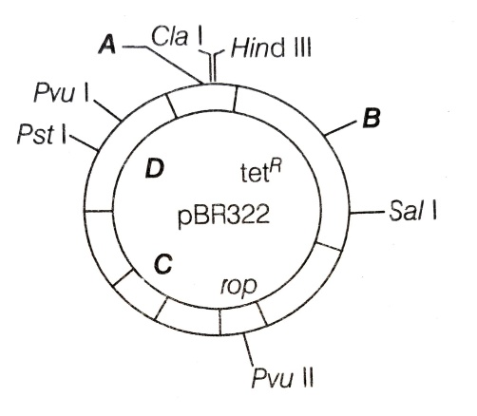

|  |  |
| --- | --- |
| a) A – Eco RI ; B – Bam HI ; C – ori ; D – ampR | b) A – ampR  ; B – ori ; C – Bam HI ; D – Eco RI |
| c) A – ori ; B – Bam HI ; C – Eco RI ; D – ampR | d) A – Bam HI ; B – Eco RI ; C – ampR ; D – ori |

1. A selectable marker is :
2. Help in eliminating the non-transformants, so that the transformant can be regenerated.
3. Identify the gene for a desired trait in an alien organism
4. Select a suitable vector for transformation in a specific crop.
5. Mark a gene on a chromosome for isolation using restriction enzymes.
6. The presence of more than one recognition site within vector will lead to the :

|  |  |
| --- | --- |
| a) Generation of several fragments | b) Generation of one fragments |
| c) Generation of half fragments | d) None of the above |

1. The recognition site for Bam HI in pBR322 is present in :

|  |  |
| --- | --- |
| a) ampicillin resistant gene | b) tetracycline resistant gene |
| c) ori site | d) rop site |

1. The given figure is the diagrammatic representation of the vector pBR322. Which one of the given options correctly identifies its certain components?

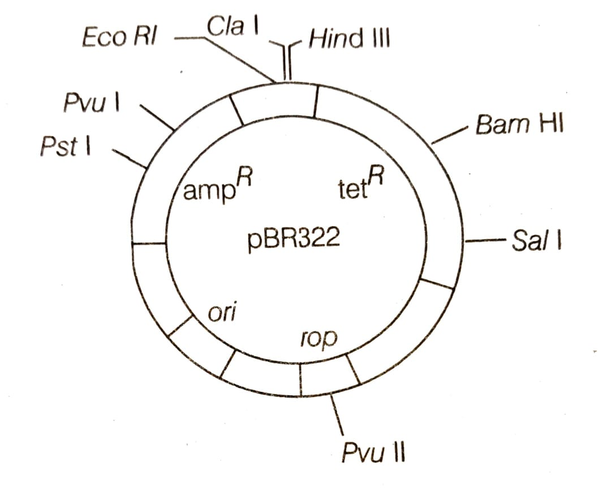

|  |  |
| --- | --- |
| a) ori = Original restriction enzymes | b) rop = reduced osmotic pressure |
| c) Hind III , Eco RI = selectable marker | d) ampR , tetR = antibiotic resistant gene |

1. When an alien DNA is ligated in tetracycline resistant gene, the recombinant :

|  |  |
| --- | --- |
| a) become tetracycline resistant | b) will loose tetracycline resistant |
| c) will remain same | d) None of the above |

BIOTECHNOLOGY : PRINCIPLES AND PROCESSES Page No. 9

1. The method(s) that is/are used to differentiate recombinants and non-recombinants is/are :

|  |  |
| --- | --- |
| a) Antibiotic affected gene | b) insertional inactivation |
| c) gene cloning | d) Both (a) and (b) |

1. In insertional inactivation, the recombinant DNA is inserted within the coding sequence of :

|  |  |
| --- | --- |
| a) $β$– galactosidase | b) tetracycline resistant gene |
| c) restriction enzyme | d) ampicillin resistant gene |

1. Recombinant colonies in insertional inactivation are differentiate on the basis of :

|  |  |
| --- | --- |
| a) Production of blue colour | b) Production of no colour |
| c) Production of red colour | d) Production of green colour |

1. *Agrobacterium tumefaciens* delivers a piece of DNA into dicot plant. The piece of DNA is called as :

|  |  |  |  |
| --- | --- | --- | --- |
| a) r – DNA | b) T – DNA | c) m – DNA | d) c – DNA |

1. Retroviruses in animals including humans are able to change normal cells into :

|  |  |  |  |
| --- | --- | --- | --- |
| a) germ cell | b) cancerous cell | c) Cosmid | d) vector |

1. The plasmid of *Agrobacterium tumefaciens* that is now modified as a cloning vector is :

|  |  |  |  |
| --- | --- | --- | --- |
| a) Pi – plasmid | b) Cosmid | c) Ti – plasmid | d) None of these |

1. The Ti-plasmid, which of the following is removed?

|  |  |
| --- | --- |
| a) Auxin gene | b) Virulent gene |
| c) Cytokinin gene | d) Auxin and cytokinin gene |

1. Why foreign DNA cannot pass through cell membrane?

|  |  |
| --- | --- |
| a) DNA is hydrophobic | b) DNA is hydrophilic |
| c) DNA is rich in proteins | d) DNA is heavy |

1. The treatment of host cell with divalent cation leads to the :
2. Change in permeability of DNA.
3. Increased efficiency with which DNA enters the bacterium.
4. Decreased efficiency with which DNA enters the bacterium.
5. Change in permeability of host.
6. The method which is used to introduce recombinant DNA into animal cell?

|  |  |
| --- | --- |
| a) Gene gun method | b) Changing permeability of Host |
| c) Biolistic method | d) Microinjection |

1. Which of the following method is used to introduce foreign DNA into plant host cells?

|  |  |  |  |
| --- | --- | --- | --- |
| a) Gene gun method | b) Gel electrophoresis | c) Elution | d) extension |

1. For transformation, microparticles coated with DNA to be bombarded with gene gun are made up of :

|  |  |  |  |
| --- | --- | --- | --- |
| a) Silver or platinum | b) Platinum or zinc | c) silicon or platinum | d) gold or tungsten |

1. DNA transfer with high velocity microparticles is present in :

|  |  |
| --- | --- |
| a) Biolistic | b) Hybridization |
| c) Tissue culture | d) Vegetative propagation |

1. Consider the following statement and select the correct options.
2. A soil inhabiting plant bacterium, *Agrobacterium tumefaciens* , a pathogen of several dicot plants is able to transfer a piece of DNA known as ‘T – DNA’.
3. The T – DNA causes tumors.
4. Tumor formation is induced by Ti plasmid.
5. All of the above

BIOTECHNOLOGY : PRINCIPLES AND PROCESSES Page No. 10

1. Which of the following statement is incorrect?
2. DNA being a hydrophilic molecule cannot pass through cell membrane.
3. *Agrobacterium tumefaciens* delivers a piece of DNA known as ‘Z – DNA’ which transforms normal plant cells into tumor cells and directs these tumor cells to produce chemicals against pathogens.
4. Retrovirus, adenovirus , papillomavirus are also now used as cloning vectors in animal because of their ability to transform normal cells into cancerous cell.
5. In genetic engineering, DNA from different sources are cut with the same restriction enzymes so that both DNA fragments have same kind of sticky ends.
6. Which of the following statement in incorrect?
7. Eco RI cuts the DNA between bases G and A.
8. Making multiple identical copies of any template DNA is called cloning.
9. pBR322 is a natural plasmid.
10. *Agrobacterium tumefaciens* is a natural genetic engineer.
11. Choose the incorrect statement.
12. Ori also controls the copy numbers of the linked DNA.
13. If a foreign DNA ligates at the Bam HI site of tetracycline resistant gene in the vector pBR322, the recombinant plasmid loses the tetracycline resistance due to insertion of foreign DNA.
14. Copy number refers to the number of copies of plasmid present in a cell.
15. Copy number of plasmid varies from 50 – 100 per cell.
16. Considered the following statement, and select the correct statements :
17. Recombinant DNA technology popularly known as genetic engineering is a stream of biotechnology which deals with the manipulation of genetic material by man in vitro.
18. pBR322 is the first artificial cloning vector developed in 1977 by Boliver and Rodriguez from E.coli plasmid.
19. Restriction enzymes belong to a class of enzymes called nucleases.

|  |  |  |  |
| --- | --- | --- | --- |
| a) I and II | b) I and III | c) II and III | d) I , II and III |

1. Read the following statement about gene gun :
2. This method is also called as Biolistic technique.
3. In this method, cells are bombarded with high velocity microparticles of gold and silver coated with DNA in plants.
4. Important crops plants like maize , rice and wheat have now been transformed by this method.

Which of the following statements given above are correct?

|  |  |  |  |
| --- | --- | --- | --- |
| a) I and II | b) I and III | c) II and III | d) I , II and III |

1. Which statement is incorrect?
2. Retroviruses have also been disarmed and are now used to deliver desirable genes into animals cells.
3. Down streaming processing is one of the steps of R-DNA technology.
4. DNA is a negatively charged molecule.
5. The presence of chromogenic substrate gives blue colour colonies, if the plasmid in the bacteria does not have an insertion.

|  |  |  |  |
| --- | --- | --- | --- |
| a) I and II | b) I , III and IV | c) All of these | d) None of these |

BIOTECHNOLOGY : PRINCIPLES AND PROCESSES Page No. 11

1. For selectable marker, choose the correct option :
2. It helps to select the host cells which contain the vector and eliminate the transformants.
3. Genes encoding resistant to antibiotics like ampicillin, chloramphenicol , tetracycline or kanamycin are useful selectable marker for E.coli.

|  |  |  |  |
| --- | --- | --- | --- |
| a) Only I | b) Only II | c) I and II | d) None of these |

1. The correct option regarding the below statement is :
2. DNA being a hydrophobic molecule cannot pass through cell membrane.
3. The bacteria be made competent to accept the DNA molecule.

|  |  |  |  |
| --- | --- | --- | --- |
| a) I is true, but II is false | b) II is true, but I is false | c) I and II are true | d) I and II are false |

1. The most important feature in a plasmid to serve as a vector in gene cloning experiment is :

|  |  |
| --- | --- |
| a) Origin of replication (ori) | b) Presence of a selectable marker |
| c) Presence of sites for restriction endonucleases | d) its size |

1. An antibiotic resistant gene in a vector usually helps in the selection of :

|  |  |
| --- | --- |
| a) Competent bacterial cells | b) Transformant bacterial cells |
| c) Recombinant bacterial cells | d) None of the above |

1. The transfer of genetic material from one bacterium to another through the mediation of a viral vector is termed as :

|  |  |  |  |
| --- | --- | --- | --- |
| a) Transduction | b) Conjugation | c) Transformation | d) Translation |

BIOTECHNOLOGY : PRINCIPLES AND PROCESSES Page No. 12

**Answers**

|  |  |  |  |  |  |  |  |
| --- | --- | --- | --- | --- | --- | --- | --- |
| 1. b | 1. c | 1. b | 1. c | 1. c | 1. d | 1. a | 1. a |
| 1. d | 1. a | 1. c | 1. a | 1. a | 1. a | 1. b | 1. d |
| 1. b | 1. b | 1. a | 1. b | 1. b | 1. b | 1. c | 1. b |
| 1. b | 1. b | 1. d | 1. a | 1. d | 1. a | 1. d | 1. b |
| 1. c | 1. d | 1. d | 1. b | 1. d | 1. b | 1. b | 1. a |
| 1. b | 1. a |  |  |  |  |  |  |

BIOTECHNOLOGY : PRINCIPLES AND PROCESSES Page No. 13

|  |
| --- |
| **Neha Malhotra**  **R.L. Institute M: 9416974837**  **Class : XII**  **“BIOTECHNOLOGY: PRINCIPLES AND PROCESSES”** |

**Level – 3**

**(Based on Processes of Recombinant DNA Technology)**

1. The different steps are involved in the process of r-DNA technology are given below randomly? Arrange these in correct order.
2. Extraction of the gene of interest.
3. Amplification of gene of interest.
4. Isolation of desired DNA fragment.
5. Ligation of the DNA fragment into vector.
6. Insertion of r-DNA into a vector.

|  |  |  |  |
| --- | --- | --- | --- |
| a) I , II , III , IV , V | b) III , II , IV , V , I | c) II , IV , V , III , I | d) I , IV , V , III , I |

1. In bacterial cells, the membrane is digested with the help of enzyme :

|  |  |  |  |
| --- | --- | --- | --- |
| a) Cellulase | b) lysozyme | c) chitinase | d) lipase |

1. RNA is removed by the treatment with :

|  |  |  |  |
| --- | --- | --- | --- |
| a) Ribonuclease | b) Cellulase | c) chitinase | d) Protease |

1. Proteins are removed by treatment with :

|  |  |  |  |
| --- | --- | --- | --- |
| a) Ribonuclease | b) Cellulase | c) chitinase | d) Protease |

1. DNA precipitation out of a mixture of biomolecules can be achieved by treatment with :

|  |  |  |  |
| --- | --- | --- | --- |
| a) chilled ethanol | b) methanol | c) shilled chloroform | d) isopropanol |

1. Purified DNA ultimately precipitates out and this can be seen as collection of fine threads in the suspension. This process is known as :

|  |  |  |  |
| --- | --- | --- | --- |
| a) DNA spooling | b) DNA digestion | c) DNA recognition | d) DNA bands |

1. DNA fragments generated by the restriction endonucleases in a chemical reaction can be separated by :

|  |  |  |  |
| --- | --- | --- | --- |
| a) Centrifugation | b) PCR | c) electrophoresis | d) restriction opening |

1. Which of the following techniques is most commonly used to separate DNA molecules by size?

|  |  |
| --- | --- |
| a) Chromatography | b) Polymerase chain reaction |
| c) spooling | d) gel electrophoresis |

1. What is the criterion for DNA fragments movements on agarose gel during gel electrophoresis?
2. The larger the fragment size, the farther it moves.
3. The smaller the fragment size, the farther it moves.
4. Positively charged fragments move to farther end.
5. Negatively charged fragments do not move.

BIOTECHNOLOGY : PRINCIPLES AND PROCESSES Page No. 14

1. Agarose is extracted by :

|  |  |  |  |
| --- | --- | --- | --- |
| a) Sea weeds | b) Blur-green algae | c) Ephedra | d) Sargassums |

1. In gel electrophoresis, restriction enzyme digested DNA is loaded in wells near :

|  |  |
| --- | --- |
| a) anode | b) cathode |
| c) center of gel | d) any where in the gel |

1. Having become an expert on gel electrophoresis, you are asked to examined a gel for a colleague, where would you find the smallest fragments of DNA?
2. Near the positive electrode, farthest away from the wells.
3. Near the negative electrode, close to the wells.
4. Near the top, near the negative pole.
5. Near the middle they tend to slow-down after the first few minutes.
6. The DNA fragments separated by an agarose gel can be visualized after staining with :

|  |  |  |  |
| --- | --- | --- | --- |
| a) Bromophenol blue | b) Acetocarmines | c) Aniline blue | d) Ethidium bromide |

1. In gel electrophoresis, the separated DNA fragments are visualized after staining the DNA with EtBr followed the exposure to _______.

|  |  |  |  |
| --- | --- | --- | --- |
| a) Infrared radiation | b) UV – radiation | c) $γ$– rays | d) Radio wave |

1. When the DNA fragments are observed under UV light, they are seen as :

|  |  |
| --- | --- |
| a) Yellow coloured bands | b) Orange coloured bands |
| c) Blue coloured bands | d) Both (a) and (b) |

1. In gel electrophoresis, the separated bands of DNA are cut out and extracted from the gel piece. This step is called :

|  |  |  |  |
| --- | --- | --- | --- |
| a) Elution | b) ORI | c) Competency | d) Transformation |

1. Polymerase chain reaction (PCR) needs :

|  |  |  |  |
| --- | --- | --- | --- |
| a) DNA template | b) Primers | c) Enzymes | d) All of these |

1. Primers are :
2. Small chemically synthesized oligonucleotides (10 – 18) that are complementary to the region of template DNA.
3. Chemically synthesized oligonucleotides (10 – 18) that are not complementary to the region of template DNA.
4. The double stranded DNA that needs to be amplified.
5. Specific sequence present on recombinant DNA.
6. The Taq polymerase enzyme is obtained from :

|  |  |
| --- | --- |
| a) Thiobacillus ferroxidans | b) Bacillus subtilis |
| c) Pseudomonas subtilis | d) Thermus aquatics |

1. A single PCR amplification cycle involves :

|  |  |  |  |
| --- | --- | --- | --- |
| a) Denaturation | b) Extension | c) Annealing | d) All of these |

1. The correct order of steps in PCR is :

|  |  |
| --- | --- |
| a) Denaturation , extension , annealing | b) Annealing , extension , Denaturation |
| c) Extension , Denaturation , Annealing | d) Denaturation , Annealing , extension |

BIOTECHNOLOGY : PRINCIPLES AND PROCESSES Page No. 15

1. The below diagram refers to PCR. Identify the steps and select the correct option.

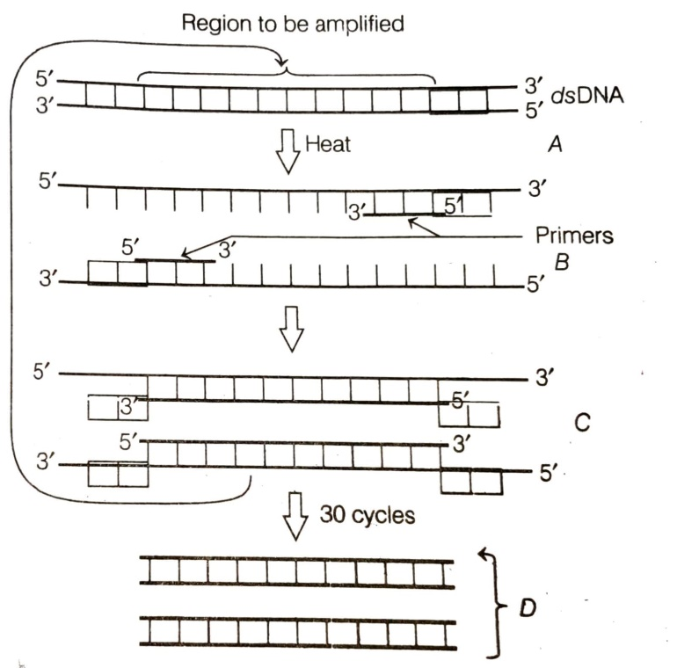

1. A – Denaturation at 94 – 96 $℃$; B – Annealing at 40 – 60 $℃$; C – Extension through Taq polymerase at 72 $℃$; D – Amplification.
2. A – Annealing at 94 – 96 $℃$; B – Denaturation at 40 – 60 $℃$; C – Extension through Taq polymerase at 72 $℃$; D – Amplification.
3. A – Extension through Taq polymerase at 72 $℃$; B – Amplification ; C – Denaturation at 40 – 60 $℃$; D – Annealing at 94 – 96 $℃$.
4. A – Amplification ; B – Extension through Taq polymerase at 72 $℃$; C – Denaturation at 40 – 60 $℃$; D – Annealing at 94 – 96 $℃$.
5. If a recombinant DNA bearing gene for ampicillin resistance is transferred into E.coli and the host cells are spread on agar plates containing ampicillin, then :
6. Both transformed and untransformed recipient cells will die.
7. Both transformed and untransformed recipient cells will grow.
8. Transformed recipient cells will grow and untransformed recipient cells will die.
9. Transformed recipient cells will die and untransformed recipient cells will grow.
10. Protein encoding gene which is expressed in heterologous host is :

|  |  |  |  |
| --- | --- | --- | --- |
| a) Foreign gene | b) Heterologous protein | c) Recombinant protein | d) Alien protein |

1. A bioreactor is :
2. Is hybridoma.
3. Cultures products containing radioactive isotopes.
4. Cultures for the synthesis of new chemicals.
5. Cultures large volumes of living cells.

BIOTECHNOLOGY : PRINCIPLES AND PROCESSES Page No. 16

1. Stirred tank bioreactors have been designed for the :
2. Purification of the product.
3. Addition of preservations to the product.
4. Availability of oxygen throughout the bioreactor.
5. Ensuring anaerobic conditions in the culture vessels.
6. Stirred-tank bioreactors are advantages over shake flasks because they :
7. Provide high temperature and pH.
8. Provide better aeration and mixing properties.
9. Do not allow the entry of CO2.
10. Are easy to operate.
11. The components of a bioreactors are :

(i) An agitator system (ii) An oxygen delivery system (iii) Foam producer

(iv) temperature control system (v) pH control system.

Choose the correct options:

|  |  |  |  |
| --- | --- | --- | --- |
| a) (i) , (ii) , (iii) , (iv) | b) (ii) , (iv) , (v) | c) (i) , (ii) , (iii) | d) (i) , (ii) , (iv) , (v) |

1. The process of separation and purification of expressed protein before marketing is called :

|  |  |
| --- | --- |
| a) Upstream processing | b) Downstream processing |
| c) Bio processing | d) Post-production processing |

1. Which of the following is not a component of downstream processing?

|  |  |  |  |
| --- | --- | --- | --- |
| a) Separation | b) Purification | c) Preservation | d) Expression |

1. Which one is a true statement regarding DNA polymerase used in PCR?
2. It is used to ligate introduced DNA in recipient cell.
3. It serves as selectable marker.
4. It is isolated from a virus.
5. It remains active at high temperature.
6. Given below 4 statements pertaining to separation of DNA fragments using gel electrophoresis. Identify the incorrect statements :
7. DNA is negatively charged molecule and so it is loaded on gel towards the anode terminal.
8. DNA fragments travel along the surface of the gel whose concentration does not affect the movement of DNA.
9. Smaller the size of DNA fragment larger is the distance it travels through it.
10. Pure DNA can be visualized directly by exposing UV-radiation.

Select the correct option from the following :

|  |  |  |  |
| --- | --- | --- | --- |
| a) I , III , IV | b) I , II , III | c) II , III , IV | d) I , II , IV |

1. Which of the following statements are correct with respect to a bio reactor?
2. It can process small volume of culture
3. It provide optimum temperature , pH , salt , vitamins and oxygen.
4. Sparged tank bioreactors is a stirred type reactor in which air is bubbles

|  |  |  |  |
| --- | --- | --- | --- |
| a) I , II | b) I , III | c) II , III | d) I , II , III |

BIOTECHNOLOGY : PRINCIPLES AND PROCESSES Page No. 17

1. Considered the following statement and select the correct option :
2. Bioreactors are vessels of small volume in which raw material are biologically converted into specific products.
3. One of the most commonly used bioreactor is of stirring type.
4. Shake flask are used for growing and mixing the desired materials on a small scale in the laboratory.
5. A large scale production of desired biotechnological product is done by using ‘bioreactors’.

|  |  |  |  |
| --- | --- | --- | --- |
| a) I , II | b) II , III , IV | c) I , II , III | d) All of these |

1. Select the following correct statements :
2. The downstream processing and quality control testing vary from product to product.
3. In bioreactors, raw materials are biologically converted into specific products.
4. Large amount of recombinant protein can be produced by gene cloning.
5. pBR322 vector was constructed by using DNA derived from naturally occurring plasmids of E.coli.

|  |  |  |  |
| --- | --- | --- | --- |
| a) I , II , IV | b) IV only | c) II , III , IV | d) all of these |

1. The role of DNA ligase in the construction of a recombinant DNA molecule is :
2. Formation of Phosphodiester bond between the DNA fragments.
3. Formation of Hydrogen bond between the sticky ends of DNA fragments.
4. Ligation of all purine and pyrimidine bases.
5. None of the above.
6. In Agarose gel electrophoresis, DNA molecules are separated on the bases of :

|  |  |  |  |
| --- | --- | --- | --- |
| a) Charge | b) size | c) Charge to size ratio | d) all of these |

1. Which of the following statement is correct in the context of visualizing DNA molecules separated by agarose gel electrophoresis?
2. DNA can be seen in visual light.
3. DNA can be seen without staining in visible light.
4. Ethidium bromide stained DNA can be seen in visible light.
5. Ethidium bromide stained DNA can be seen under exposure of UV – light.
6. While isolating DNA from bacteria, which of the following enzymes is not required?

|  |  |  |  |
| --- | --- | --- | --- |
| a) Lysozyme | b) Ribonucleases | c) Deoxyribonucleases | d) Protease |

1. Which of the following contributed popularizing the PCR technique?

|  |  |
| --- | --- |
| a) Easy availability of DNA template | b) Availability of synthetic primers. |
| c) Availability of cheap deoxyribonucleotides | d) Availability of thermostable DNA polymerase. |

1. Who among the following was awarded the Nobel prize for the development of PCR technique?

|  |  |  |  |
| --- | --- | --- | --- |
| a) Herbert Boyer | b) Har Govind Khorana | c) Kary Mullis | d) Arthur Kornberg |

1. Which of the following steps are catalyzed by Taq polymerase in a PCR reaction?

|  |  |
| --- | --- |
| a) Denaturation of template DNA | b) Annealing of primers to template DNA |
| c) Extension of primer end on the template DNA | d) All of these |

BIOTECHNOLOGY : PRINCIPLES AND PROCESSES Page No. 18

1. Match column I and column II

|  |  |  |
| --- | --- | --- |
| Column I | Column II | |
| A. Recombinant DNA | I. Sea weeds | |
| B. Gel electrophoresis | II. DNA staining | |
| C. Ethidium bromide | III. Plasmid DNA that has incorporated human DNA | |
| D. Agarose | IV. Process by which DNA fragments are separated based  on their size. | |
| a) A – III ; B – IV ; C – II ; D – I | | | b) A – III ; B – II ; C – I ; D – IV | |
| c) A – II ; B – I ; C – IV ; D – III | | | d) A – III ; B – IV ; C – I ; D – II | |

1. Match column I and column II

|  |  |  |
| --- | --- | --- |
| Column I | Column II | |
| A. Bacterial cell is treated with | I. Lysozyme | |
| B. Plant cell is treated with | II. Cellulase | |
| C. Fungal cell is treated with | III. Chitinase | |
| a) A – III ; B – II ; C – I | | | b) A – II ; B – III ; C – I | |
| c) A – I ; B – II ; C – III | | | d) A – III ; B – I ; C – II | |

1. Match column I and column II

|  |  |  |
| --- | --- | --- |
| Column I | Column II | |
| A. Isolation of purified DNA | I. Restriction enzyme | |
| B. Cutting of DNA at specific location | II. Gel electrophoresis | |
| C. Isolation of DNA fragments | III. Chilled ethanol | |
| D. Amplification of gene | IV. PCR | |
| a) A – I ; B – II ; C – III ; D – IV | | | b) A – III ; B – I ; C – II ; D – IV | |
| c) A – II ; B – I ; C – III ; D – IV | | | d) A – III ; B – II ; C – I ; D – IV | |

BIOTECHNOLOGY : PRINCIPLES AND PROCESSES Page No. 19

**Answers**

|  |  |  |  |  |  |  |  |
| --- | --- | --- | --- | --- | --- | --- | --- |
| 1. b | 1. b | 1. a | 1. d | 1. a | 1. a | 1. c | 1. d |
| 1. b | 1. a | 1. b | 1. a | 1. d | 1. b | 1. b | 1. a |
| 1. d | 1. a | 1. d | 1. d | 1. d | 1. a | 1. c | 1. c |
| 1. d | 1. c | 1. b | 1. d | 1. b | 1. d | 1. d | 1. d |
| 1. c | 1. b | 1. d | 1. a | 1. b | 1. d | 1. c | 1. d |
| 1. c | 1. c | 1. a | 1. c | 1. b |  |  |  |

BIOTECHNOLOGY : PRINCIPLES AND PROCESSES Page No. 20